Mini Project: Customer Sales Insights
- Who are the top 5 customers?

Query –
WITH CustomerSales AS
(SELECT
c.[Customer ID],
c.[Customer Name],
SUM(o.Sales) AS TotalSales
FROM customers c
JOIN orders o
ON c.[Customer ID] = o.[Customer ID]
GROUP BY
c.[Customer ID],
c.[Customer Name] )
SELECT
[Customer Name],
TotalSales
FROM CustomerSales
ORDER BY TotalSales DESC
LIMIT 5;
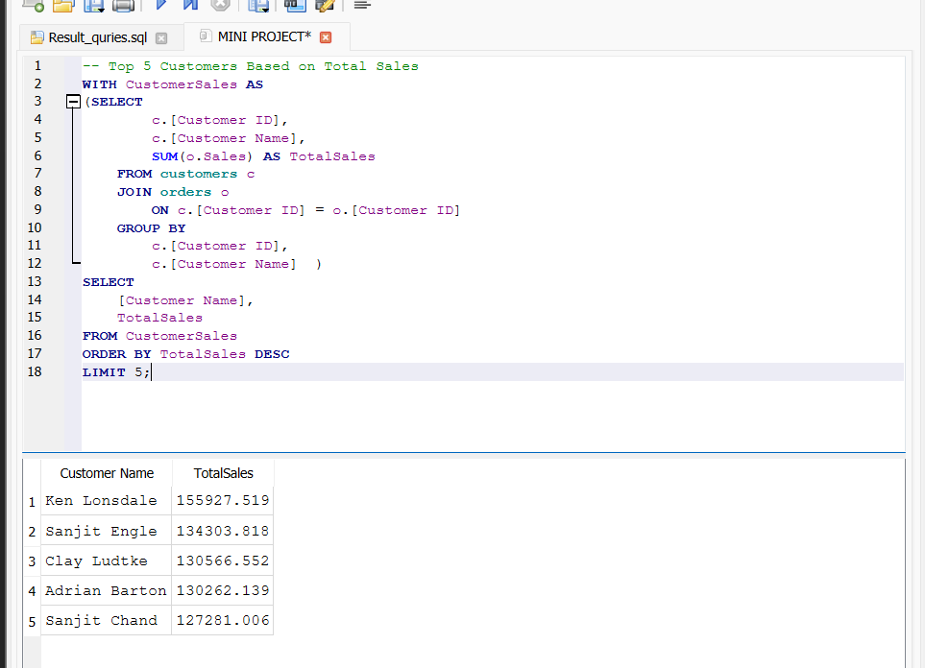
This query calculates the total sales made by each customer by summing the sales values from all their orders. It then sorts the customers in descending order based on total sales and displays the top five customers with the highest sales. This helps identify the business's most valuable customers.
Insights
- Identifies the highest revenue-generating customers.
- These customers can be targeted with loyalty programs and special offers to improve customer retention.

- Who are the Bottom 5 Customers?
Query - WITH CustomerSales AS
(SELECT
c.[Customer ID],
c.[Customer Name],
SUM(o.Sales) AS TotalSales
FROM customers c
JOIN orders o
ON c.[Customer ID] = o.[Customer ID]
GROUP BY
c.[Customer ID],
c.[Customer Name] )
SELECT
[Customer Name],
TotalSales
FROM CustomerSales
ORDER BY TotalSales ASC
LIMIT 5;
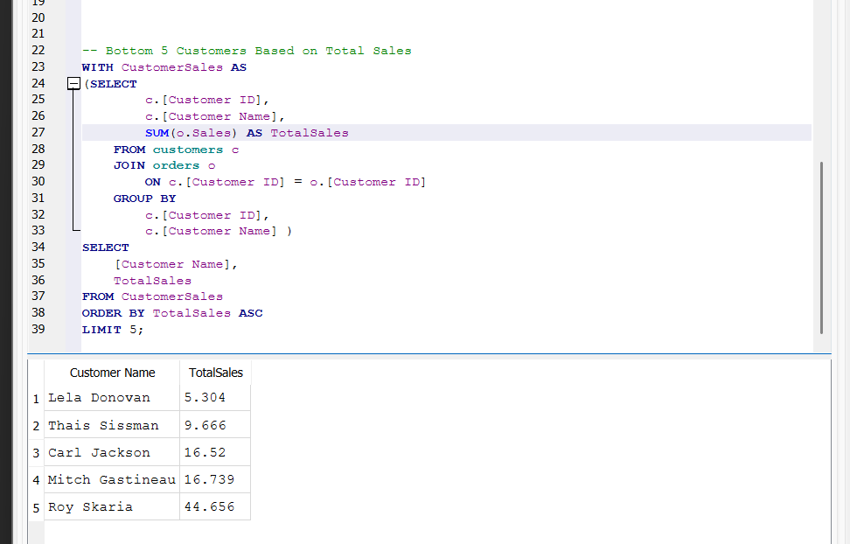
This query calculates the total sales for each customer and sorts the results in ascending order. It returns the five customers with the lowest total sales. This analysis helps identify customers who contribute the least to the overall revenue.
Insight
- Identifies low-value customers.
- Businesses can engage these customers through discounts, personalized marketing, or promotional campaigns to increase future sales.

- Which customers made only one order?
Query – SELECT
c.[Customer ID],
c.[Customer Name],
COUNT(o.[Order ID]) AS TotalOrders
FROM customers c
JOIN orders o
ON c.[Customer ID] = o.[Customer ID]
GROUP BY
c.[Customer ID],
c.[Customer Name]
HAVING COUNT(o.[Order ID]) = 1;
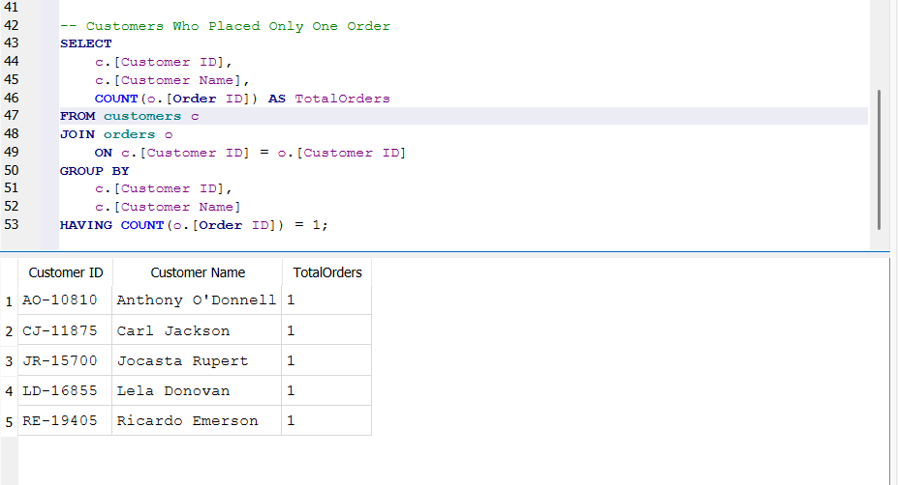
This query counts the number of orders placed by each customer using the COUNT() function. It groups the data by customer and displays only those customers who have placed exactly one order using the HAVING clause.
Insight
- Identifies one-time customers.
- Businesses can encourage repeat purchases by offering follow-up discounts, reward points, or personalized recommendations.

- Which customers have above-average sales?
Query – WITH CustomerSales AS
(SELECT
c.[Customer ID],
c.[Customer Name],
SUM(o.Sales) AS TotalSales
FROM customers c
JOIN orders o
ON c.[Customer ID] = o.[Customer ID]
GROUP BY
c.[Customer ID],
c.[Customer Name] )
SELECT
[Customer Name],
TotalSales
FROM CustomerSales
WHERE TotalSales >
( SELECT AVG(TotalSales)
FROM CustomerSales )
ORDER BY TotalSales DESC;
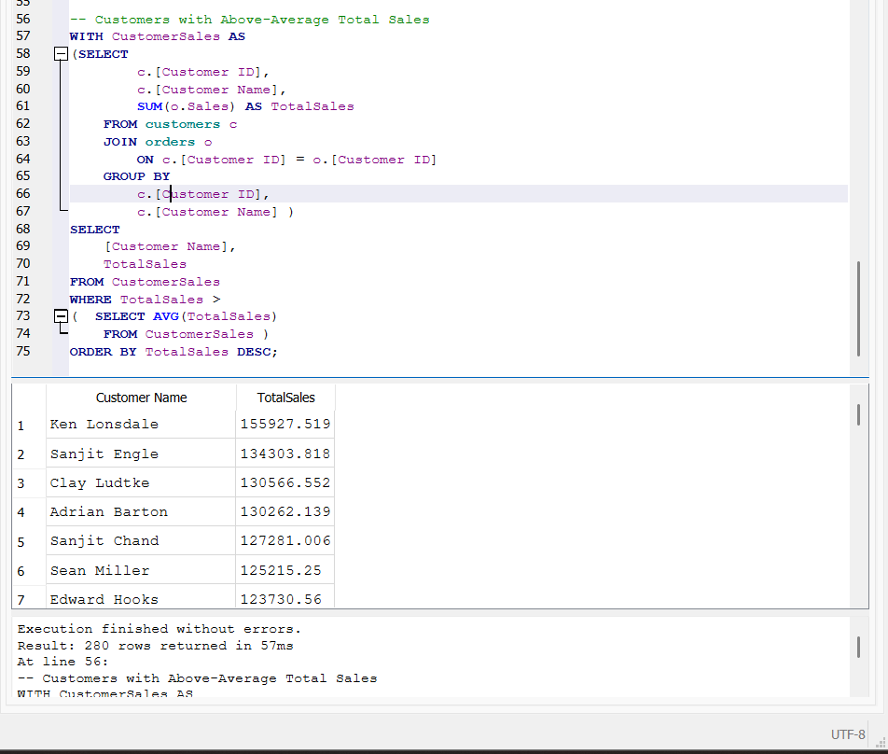
This query first calculates the total sales of every customer using a Common Table Expression (CTE). It then calculates the average of these total sales using a subquery. Finally, it displays only those customers whose total sales are greater than the average customer sales.
Insight
- Identifies customers who spend more than the average.
- These high-value customers are important for business growth and should be retained through premium services and personalized engagement.

- What is the highest order value per customer?
Query – SELECT
c.[Customer ID],
c.[Customer Name],
MAX(o.Sales) AS HighestOrderValue
FROM customers c
JOIN orders o
ON c.[Customer ID] = o.[Customer ID]
GROUP BY
c.[Customer ID],
c.[Customer Name]
ORDER BY HighestOrderValue DESC;
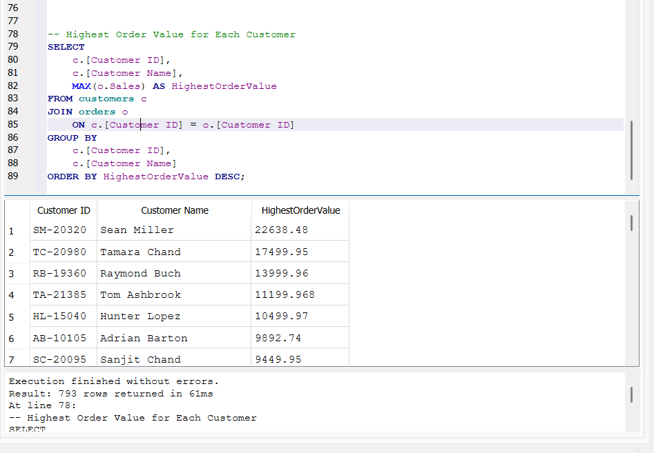
This query uses the MAX() function to find the highest sales value (largest order) for each customer. It groups the data by customer and returns the maximum order value placed by every customer.
Insight
- Shows the highest-value purchase made by each customer.
- Helps understand customers' peak spending behaviour and supports targeted sales and marketing strategies.

